Using the  [FIFA World Ranking](https://en.wikipedia.org/wiki/FIFA_World_Rankings) and the [Elo rating system](https://en.wikipedia.org/wiki/Elo_rating_system) we will try to estimate the probability of England winning its first Euro in history! The expected result of a game is given by the formula:

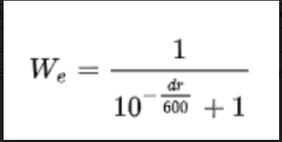

where dr is the difference between two teams’ ratings before the game. Let’s see the function of the Winning Probability versus the Ranking Difference:

diffs<-seq(-1000,1000)

probs<-1/(1+10^(-(diffs)/600))

plot(diffs, probs, main="Winning Probability vs Ranking Difference", xlab = "Ranking Differences", ylab = "Winning Probability")

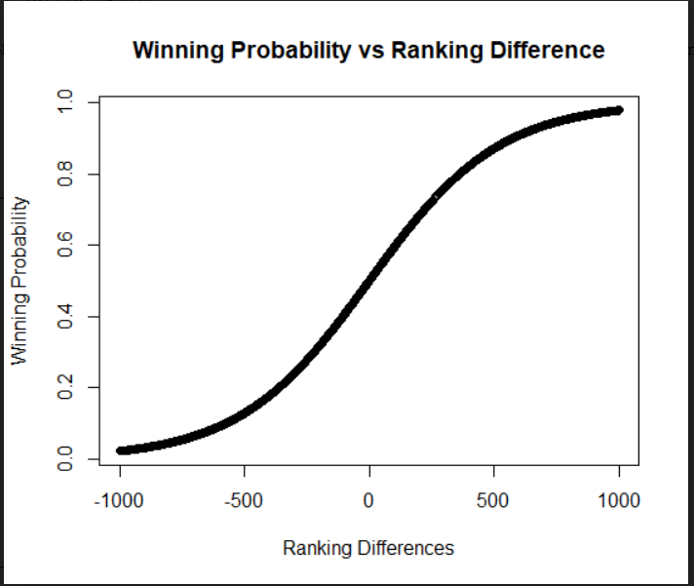

**The Wembley Factor**

Provided that England will qualify for the Finals, it will play both games in Wembley, i.e at Home. This is a key factor in the predictions. Looking at the descriptive statistics in Premier League, teams consistently **win around** **46.2%** of home games, while the draw occurs **around 27.52%** of the time and the **away team is victorious in 26.32%** of games. If we normalize the probability to win by excluding “draws” (46.2/(46.2+26.32)) we get that the probability to win is **63.7%**. This is the “Wembley factor” to qualify for the next two games.

**How the Home Effect is Translated in ELO System**

In order to adapt the Home Effect in the Winning probability, we will need to find out what is the required difference for a team to have 63.7% chances to win. We can solve it numerically.

diffs[(probs>0.637)][1]

[1] 147

Thus, the Wembley effect is like a boost of **147** points in the ELO System.

**Probability to Qualify to Finals**

Taking into consideration the Wembley Effect and the ELO Winning Formula, the probability to qualify against Denmark is **68.46%**.

england = 1687 + 147

denmark = 1632

1/(1+10^(-(england-denmark)/600))

[1] 0.6846455

**Probability to Win Euro 2020**

In the finals will be either Italy or Spain where both teams have the same FIFA Ranking. Let’s see what will be the probability to win Spain.

england = 1687 + 147

spain = 1648

1/(1+10^(-(england-spain)/600))

[1] 0.6712406

According to the formula, the probability is **67.12%**. Thus to probability to win the Euro 2020 is 67.12% x 68.46% = **45.95%**.

So according to this approach, England has around 46% chances to win the Euro for the first time in history!